Unite MSC / NRTMC Automation Executive Status
Visual leadership update for Kevin Daines | QA Automation | August 7, 2026

Executive snapshot: Mobile 2 is fully available, Mobile 1 is effectively complete at roughly 90%, Enrollment is now the active build-out area, and pipeline / nightly regression work is moving in parallel. Performance testing is progressing, but it should be shown separately because the work requires research, baseline validation, stable data, and repeatable environment runs before it becomes scheduled regression.

1. Program Metrics at a Glance
Leadership view: this chart uses relative readiness for executive tracking. It is not source-code coverage.
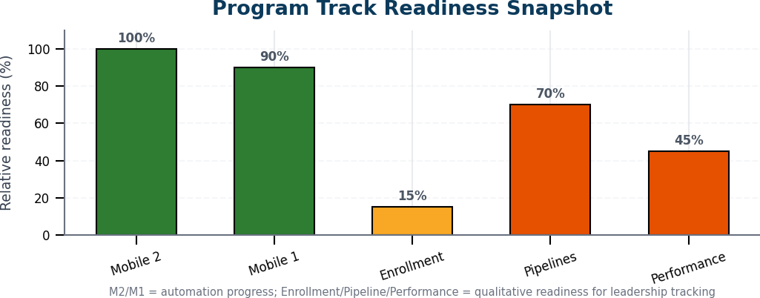
Track | Status | Approx. | RAG / leadership message
Mobile 2 | Complete | 100% | Available today; ready for sign-off / ongoing regression use.
Mobile 1 | Effectively complete | ~90% | Major flows in place; minor gap review should not block the broader program.
Enrollment | In progress | ~15% | Active sprint focus: first end-to-end vertical slice.
CI / Pipelines | In parallel | Qualitative | GitLab and GitHub nightly wiring in progress.
Performance | Research + baseline path | Qualitative | Treat as scenario readiness, not simple endpoint coverage.

2. Automation Coverage Snapshot
Endpoint counts are approximate leadership indicators from the current update. Enrollment is represented as E2E flow units because final endpoint scope is still expanding.
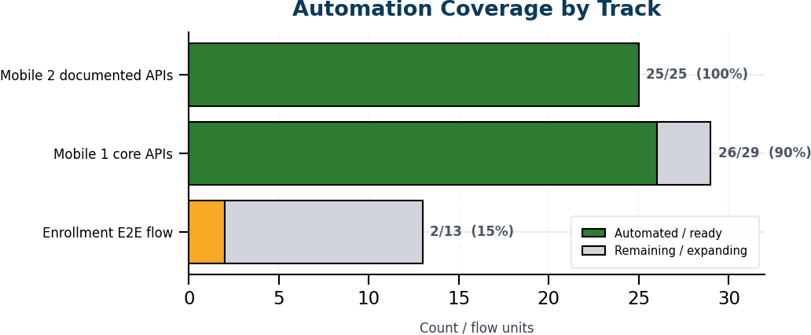
Area | Scope | Automated / ready | Approx. | Available today?
Mobile 2 | 25 business APIs | 25 | 100% | Yes - master integration + regression suites
Mobile 1 | ~29 core APIs | ~26 | ~90% | Yes - module suites; minor gaps under review
Enrollment | ~13-step E2E flow | In progress | ~15% | Docs + Postman ready; automation vertical slice in progress
What is available today: Mobile 2 is complete and ready for sign-off / ongoing use. Mobile 1 is effectively complete with only minor gap review remaining. Enrollment is now the active delivery focus, and pipeline wiring is moving in parallel.

3. Performance Testing Readiness
Performance work is more difficult to summarize as a simple percent. The better executive view is scenario readiness: baseline complete, in progress, available but not scheduled, or still in research / prioritization.
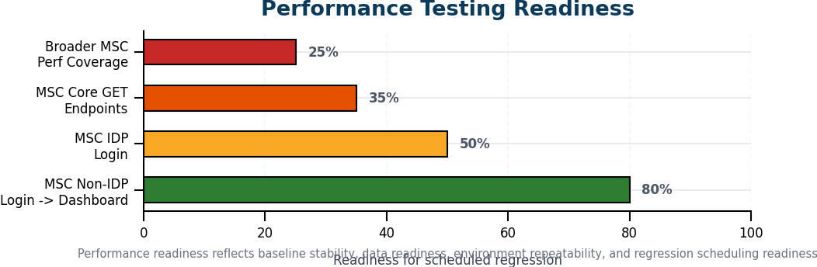
Scenario | Current status | Leadership-friendly interpretation
MSC Non-IDP Login -> Dashboard | Baseline complete | First MSC baseline is available and can be used for trend comparison.
MSC IDP Login | In progress | Needs final stabilization before it becomes a reliable scheduled regression item.
MSC Core GET Endpoints | In repo, not scheduled | Available as implementation work, but not yet part of the regression rhythm.
Broader performance coverage | Research / prioritization | Requires test-data prep, baseline analysis, and clean repeatable runs before scheduling.

Suggested Note to Send
Hi Kevin,
Here is the high-level Unite MSC / NRTMC automation status. Mobile 2 is complete, Mobile 1 is effectively complete at roughly 90%, and the team is now focused on Enrollment plus the remaining pipeline wiring.
For what is available today, Mobile 2 is ready for sign-off / ongoing regression use and Mobile 1 has the major core flows in place with only minor gap review remaining. Enrollment is active, with the first end-to-end vertical slice as the current delivery focus.
Performance is progressing, but I would position it separately because performance cases need research, stable data, baseline validation, and clean repeatable runs before they become scheduled regression items. The MSC Non-IDP baseline is complete, MSC IDP is in progress, and core GET endpoint scripts are available but not yet scheduled.
Thanks,
Swapnil

Source Basis and Guardrails
- Based on the attached 2026-08-07 Kevin status update: Mobile 2 100%, Mobile 1 ~90%, Enrollment active vertical slice, and pipeline work in progress.
- Based on the attached performance-testing notes: MSC Non-IDP baseline complete, MSC IDP in progress, MSC Core GET endpoints in repo but not scheduled.
- Visual percentages for Pipelines and Performance are leadership-readiness indicators, not formal source-code coverage or audited completion metrics.

